**Q1. EXPLAIN POWER QUERY ARCHITECTURE?**

**Power Query** is a platform to READ (Extract), OPERATE (Transform) and LOAD any data into Power BI. Using Power Query we can perform Union, Merge, Sort, Search, Pivot, Group By, Replace, Filter, etc...

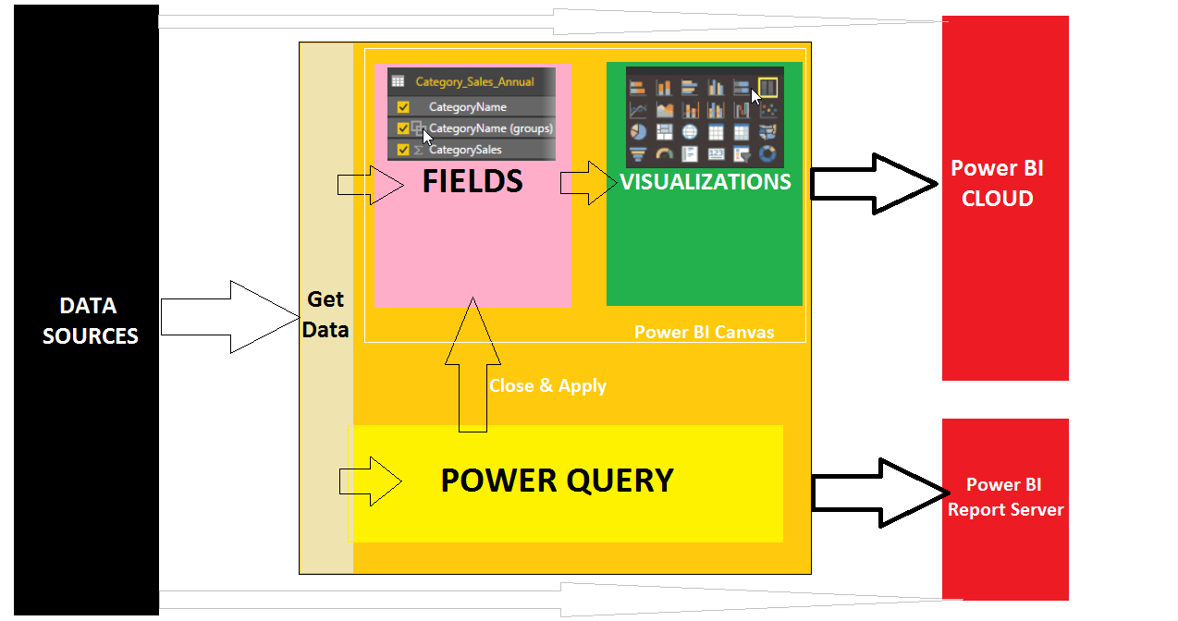

**OPERATIONS WE CAN PEFORM USING POWER QUERY**

**OPERATION 1: "GET DATA" [STATIC or DYNAMIC]**

**OPERATION 2: TRANSFORMATIONS [Operations, Calculations]**

**OPERATION 3: LOAD DATA INTO POWER BI CANVAS FOR REPORTING**

**TYPES OF QUERIES IN POWER QUERY**

|  |  |  |  |
| --- | --- | --- | --- |
| **1** | **TABLE QUERIES** | **4** | **RECORD QUERIES [JSON]** |
| **2** | **LIST QUERIES** | **5** | **PARAMETER QUERIES** |
| **3** | **FUNCTION QUERIES** |  |  |

**DATA TYPES FOR ABOVE VALUES IN POWER QUERY**

|  |  |  |
| --- | --- | --- |
|  |  |  |
| Decimal Number | Date and Time | Text |
| Fixed Decimal Number | Date | True / False |
| Whole Number | Time | Binary |
| Percentage | Date / Time / TimeZone | **Any** [default data type] |

**Q2. WHAT ARE THE DIFFERENT WAYS TO CONDITIONALLY ACCESS DATA IN POWER BI ?**

By Using Parameters

By Using Conditions in queries if the data source is a Database

**Q3. WHAT ARE THE TEXT TRANSFORMTIONS?**

PROPER; SPLIT; FORMAT; MERGE; EXTRACT; PARSE; UPPERCASE;

**Q4. WHAT ARE THE TABLE TRANSFORMATIONS?**

COMBINE; GROUP BY; TRANSPOSE; REVERSE ROWS; COUNT ROWS;

**Q5. HOW TO PIVOT MORE THAN ONE SUMMARY VALUE?**

It is not possible directly. Instead, we need to pivot one column at a time.

Finally APPEND all the resulting pivoted queries into one.